Python Assignment:

**1) There are two numbers 3358 & 2583, 3 can be replaced by 8, and 8 can be replaced by 3. List out all combinations of interchangeable numbers and display maximum, minimum and average of the numbers.**

Output:

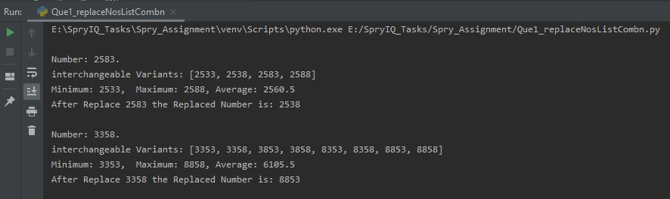

**2) Generate a log file which includes logger event, from  
 a) ERROR,  
 b) WARNING,  
 c) INFO,  
 d) DEBUG &  
 e) CRITICAL**  
along with random numbers in the range 120 to 130. Write 20 rows with random date/time stamp in human readable format. (Logger events should be random from list, your output gives only CRITICAL. Also the date in the logs are not random)Eg  
CRITICAL:125 12th August 2019 17.50  
CRITICAL:121 12th August 2019 16.50  
ERROR:123 12th August 2019 19.20  
And so on  
Further count the logger events and display as following:  
CRITICAL: occurs 5 times  
CRITICAL Code 125: occurs 2 times  
CRITICAL Code 121: occurs 3 times  
  
ERROR: occurs 10 times  
ERROR Code 123: occurs 4 times  
ERROR Code 129: occurs 6 times

Output:

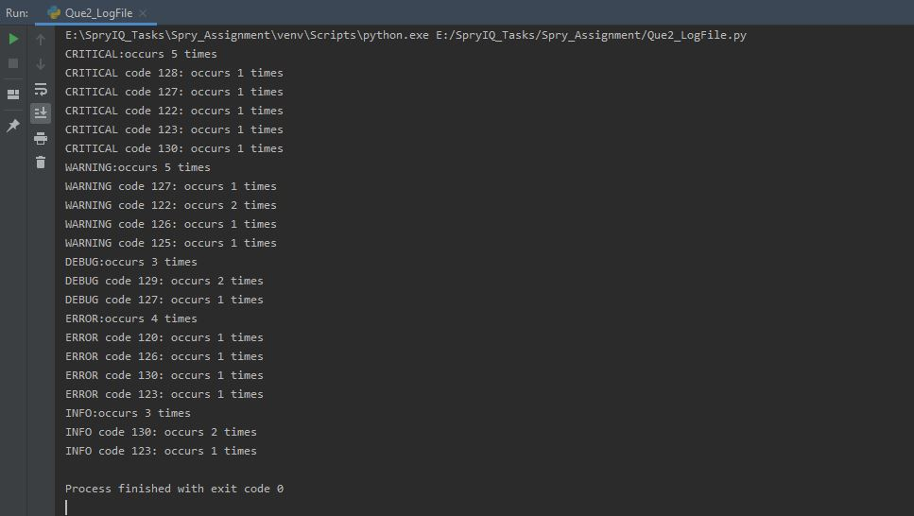

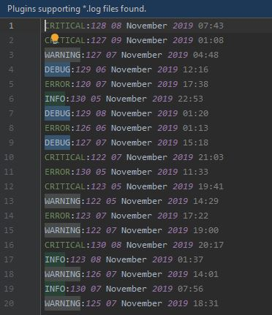

**3) Generate 10 random numbers, add them to a list and print the list.  
If the program is ran 2 times, different set of numbers should be printed.  
Additional difficulty, the numbers should be less than 100.**

Output:

When Run First time the below 10 random numbers appear

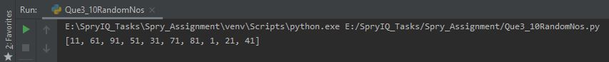

When Run second time the below 10 random appears



**4). Accept a string as input. Reverse the order of words in a string.  
e.g. if string input is "Today is Wednesday"  
the output should be "Wednesday is Today"**

Output:

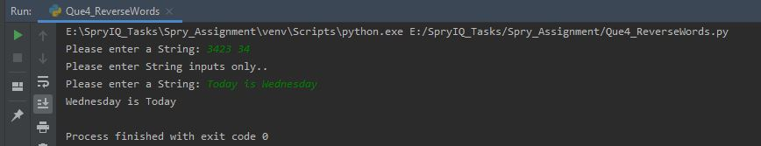

**5). Rock, Paper, Scissor assignment. Implement game of rock, paper, scissors.  
Take input from user and randomly generate for the computer. Print the output and result.  
Play game of best of 5.  
The inputs accepted as well as the outputs printed should be properly formatted and displayed.  
Input from either of the following should be accepted:  
For rock : r, rock, Rock, ROCK  
For paper : p, paper, Paper, PAPER  
For scissor : s, scissor, Scissor, SCISSOR**

Output:

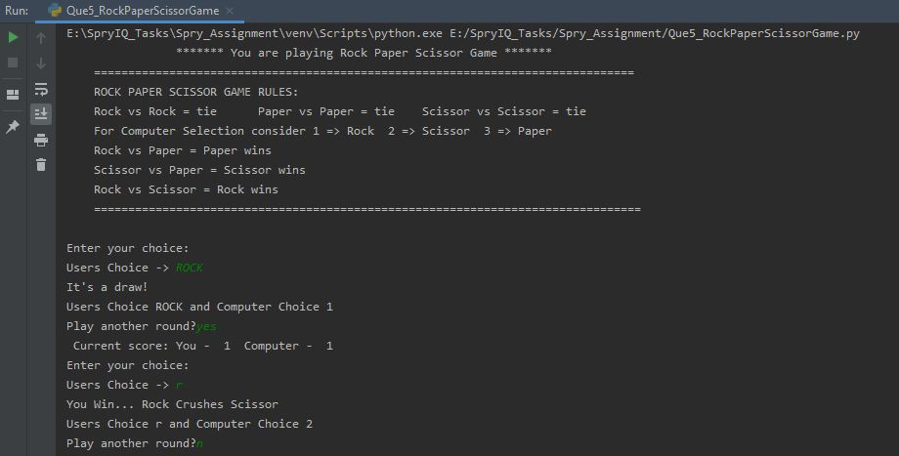

**6). Accept a list of numbers as input. Print the numbers that appear only once in the list.**

Output:

